Overview

Contoso are a manufacturer of car components with a headquarters in London and satellite offices in Amsterdam and Munich. Contoso are going through a large digital transformation program at the moment where they are rationalising their data centre estate and moving much of their enterprise infrastructure to Azure.

The London office has 2,000 users. The Amsterdam office has 500 users. The Munich office has 500 users. All existing resources within Contoso’s enterprise estate are hosted in data centre facilities in either London or Amsterdam.

Contoso are already using Microsoft 365 for modern workplace services therefore already have an existing Azure AD tenant. They have no active Azure subscriptions.

Existing Environment

The existing network contains an Active Directory with the primary domain name of contoso.com. All Domain Controllers have integrated DNS and host the contoso.com DNS zone. Domain Controllers are deployed in pairs in both the London and Amsterdam data centres.

Contoso’s business is dividend into departments which are:

* Finance
* Human Resources
* Supply Chain
* Sales

Each department has its own organisational unit within the existing Active Directory. Each user account within the Active Directory has the department attribute set to match the users main working area within the business.

The existing data centre facilities are managed by different service providers. They facilities at London and Amsterdam are connected via an MPLS circuit provided by British Telecom. In addition to this MPLS circuit, there is also S2S VPNs between London and Amsterdam provisioned as a backup route to the MPLS circuit. These VPNs are terminated into Cisco ASA firewalls which sit within the management boundary of Contoso in each of the data centres.

A production application known as CarPartsSystem has been selected as the first application to be migrated to Azure as part of the initial POC. This application is currently running on a Hyper-V Cluster which sits within London. Hyper-V Replica is configured to replicate the application servers to Amsterdam for a warm failover capability. Contoso has F5 Big-IP Load Balancers to load balance and ensure high availability of the multiple tiers within the application. The application is built on Windows Server and SQL. It is a traditional 3-tier application architecture.

* Web tier – this is Windows Server 2016 with IIS installed and ASP.net webforms
  + The web tier is presented over port 443 (HTTPS).
* Application tier – this is Windows Server 2016 with C# class libraires and middleware
  + The web and application tier communicate over port TCP 399
  + The application tier and database tier communicate over port TCP 1387
* Database tier – this is Windows Server 2019 with SQL 2018 and a large scale 1TB database
  + No communication is currently open between the web and database tier Web

The following diagram outlines the high-level architecture of the application.

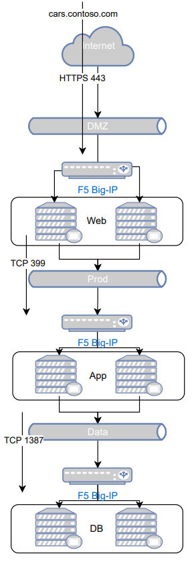

You have successfully won a consulting project with Contoso and their internal IT Manager has been reading up on Azure. During a discovery workshop with the IT Manager a number of functional and non-functional requirements have been gathered.

Requirements

|  |  |  |
| --- | --- | --- |
| 1 |  |  |
| 2 |  |  |
| 3 |  |  |
| 4 |  |  |
| 5 |  |  |
| 6 |  |  |
| 7 |  |  |
| 8 |  |  |
| 9 |  |  |
| 10 |  |  |
| 11 |  |  |
| 12 |  |  |
| 13 |  |  |
| 14 |  |  |
| 15 |  |  |